Smart Insole Cyber-Physical Alert System for Early Prevention of Diabetic Foot Ulcers: Design, Implementation, and Experimental Validation
Shahinaz H. Abdelraouf1*¹,
1 MUC University in Cairo, Faculty of Engineering, Robotics Engineering, Cairo, Egypt.
* Corresponding author’s email: shahinaz.mohamed@muc.edu.eg

# | Student Name | Student ID | University Account
1 | Mohamed Omar Nassar | [24120450] | Mohamed.24120450@muc.edu.eg
2 | Yousef Ahmed Elaaser | [24120410] | Yousef.24120410@muc.edu.eg
3 | Habiba Tamer Mohamed | [24120470] | Habiba.24120470@muc.edu.eg
4 | Mariam Ahmed Elsayed | [24120376] | Mariam.24120376@muc.edu.eg

Received:  Accepted:  Published: | ABSTRACT  Diabetic foot complications represent one of the most debilitating and costly consequences of diabetes mellitus, often leading to chronic ulceration and lower-limb amputation. Conventional clinical monitoring is inherently limited by infrequent patient visits, and affected individuals frequently lack protective pain sensation due to peripheral neuropathy, leaving pathological conditions undetected until irreversible damage occurs. This paper presents the design and implementation of an integrated smart insole system — a compact, wearable Cyber-Physical Alert System (CPAS) — engineered specifically for the early detection and prevention of diabetic foot ulcers. The proposed system embeds five complementary sensors within a flexible insole: an NTC thermistor for real-time skin temperature monitoring, a DHT22 sensor for intra-shoe humidity and ambient temperature measurement, a Velostat-based pressure mapping array for plantar pressure distribution, an MPU6050 inertial measurement unit for gait analysis and abnormal motion detection, and a MAX30102 optical sensor for peripheral blood flow estimation. The system's cyber layer integrates a feedback-driven control algorithm that continuously correlates multi-parameter data against clinically validated thresholds. Experimental validation demonstrates a system response latency of under one second — a reduction of more than 80% compared to conventional periodic clinical assessment. The entire system was realized at a component cost below 70 USD, establishing a highly cost-effective platform suitable for home use and large-scale preventive healthcare deployment.  Keywords: Diabetic Foot Ulcer; Smart Insole; Cyber-Physical System; Wearable Sensors; Plantar Pressure; NTC Thermistor; MPU6050; Preventive Healthcare; Real-Time Monitoring

Introduction
Diabetes mellitus is one of the most prevalent chronic diseases worldwide, affecting over 537 million adults as of 2021, a figure projected to exceed 780 million by 2045 [1]. Among its diverse and debilitating complications, diabetic foot disease stands out as a leading cause of preventable morbidity, hospitalization, and long-term disability. A diabetic foot ulcer (DFU) is an open wound that most commonly develops on the plantar surface of the foot. Due to the chronic hyperglycemic environment, tissue healing is severely impaired, and even minor mechanical injuries can progress to deep infections involving underlying structures
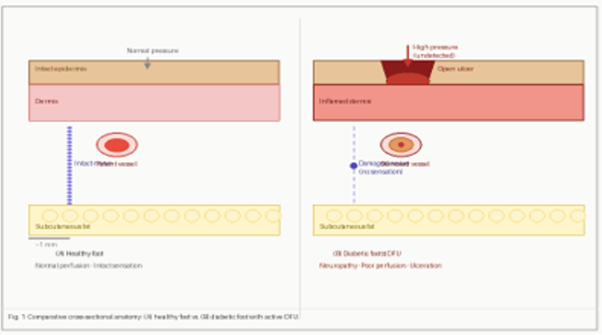
Figure 1. 1 Industry 4.0 [1]

The International Diabetes Federation estimates that a lower-limb amputation occurs somewhere in the world every 20 seconds as a direct consequence of a diabetic foot ulcer. Peripheral neuropathy, present in approximately 50% of patients with long-standing diabetes, progressively eliminates the protective sensation of pain, pressure, and heat from the foot. This silent loss of sensation transforms minor injuries into devastating complications, as patients remain unaware of developing wounds until they progress to severe infections or tissue necrosis. The economic burden is staggering, with diabetic foot complications costing healthcare systems billions annually in hospitalizations, antibiotics, surgical interventions, and rehabilitation. Furthermore, the five-year mortality rate following a major amputation exceeds that of many common cancers, highlighting that diabetic foot disease is not merely a limb-threatening condition but a life-threatening one. Despite these grim statistics, up to 85% of amputations are preventable through early detection, proper foot care education, and multidisciplinary management, making screening and prevention programs critical investments in both human lives and healthcare resources.



Clinical management of diabetic foot currently relies on periodic outpatient assessment, typically scheduled every four to eight weeks. However, the conditions that precipitate ulceration can develop and cause irreversible tissue damage within a matter of hours [3]. The temporal gap between clinical appointments represents a window of vulnerability that conventional care models cannot adequately address.
Existing commercial wearable systems for diabetic foot monitoring, such as the Orpyx SurroSense Rx and Siren Diabetic Socks, have demonstrated meaningful clinical benefit but are constrained by high cost (often exceeding 1,000 USD), limited sensing modalities, and dependence on external smartphone applications for data processing. These limitations reduce their accessibility for patients in low- and middle-income settings, where the burden of diabetes is disproportionately high

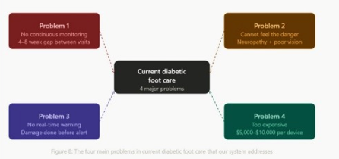

This paper presents the design, hardware implementation, and experimental validation of a low-cost, self-contained smart insole system — the Cyber-Physical Alert System (CPAS) — that integrates five complementary sensing modalities with an on-board embedded processing core and dual-mode actuation. Unlike passive monitoring systems, CPAS closes the feedback loop by delivering real-time therapeutic and alert responses directly to the patient without reliance on an external computing device.

RELATED WORK
Research into wearable systems for diabetic foot monitoring has developed along three broad trajectories: pressure-centric systems, thermal monitoring platforms, and multi-modal integrated solutions.

Pressure-Based Monitoring Systems
The earliest wearable insole systems focused exclusively on plantar pressure measurement, motivated by the well-established link between sustained elevated pressure and the formation of pre-ulcerative callus and open wounds. Pappas et al. (2004) developed one of the first embedded pedobarographic systems using capacitive pressure cells [4]. The commercially available Orpyx SurroSense Rx system extended this concept, providing real-time pressure feedback via a companion smartphone application. However, pressure alone provides an incomplete picture of foot health.

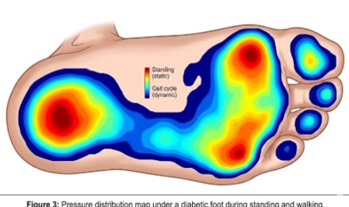

2.2 Thermal Monitoring Approaches
Elevated skin temperature is recognized as an early and objective indicator of tissue inflammation that precedes ulceration by days to weeks. Lavery et al. demonstrated that a temperature differential greater than 2°C between corresponding contralateral foot sites was predictive of imminent ulceration, and that daily home thermal monitoring could reduce ulcer incidence by up to 44% [5]. Despite its clinical promise, the Siren Diabetic Sock provides no actuation capability and cannot measure pressure, gait, or humidity.

2.3 Multi-Modal and Cyber-Physical Approaches
More recent research has sought to combine multiple sensing modalities to improve diagnostic specificity. Hazari et al. (2020) proposed an IoT-based insole integrating pressure and temperature sensors with cloud connectivity [6]. Investigations incorporating IMU-based gait analysis have further shown that kinematic asymmetries correlate with harmful focal loading patterns [7]. The present work addresses these limitations by implementing on-device closed-loop processing with dual actuator responses.

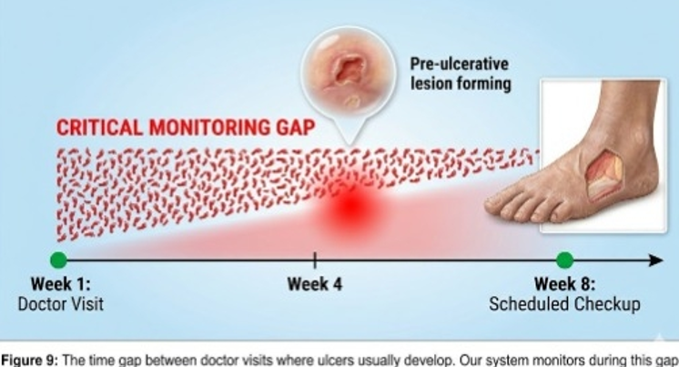

3. SYSTEM ARCHITECTURE AND HARDWARE DESIGN

3.1 Overall System Architecture
The proposed smart insole system is designed as an integrated wearable healthcare solution aimed at continuous monitoring and early prevention of diabetic foot complications. The design combines a Physical Layer — consisting of embedded sensors and actuators — with a Cyber Layer responsible for data processing, decision-making, and control logic. The five sensing modalities — skin temperature (NTC thermistor), intra-shoe humidity and ambient temperature (DHT22), plantar pressure distribution (Velostat-based resistive matrix), tri-axial acceleration and angular velocity for gait analysis (MPU6050 IMU), and peripheral photoplethysmographic signal for perfusion estimation (MAX30102) — collectively provide a comprehensive physiological profile. The system is powered by an 800 mAh lithium-polymer rechargeable battery, achieving greater than 10 hours of continuous operation

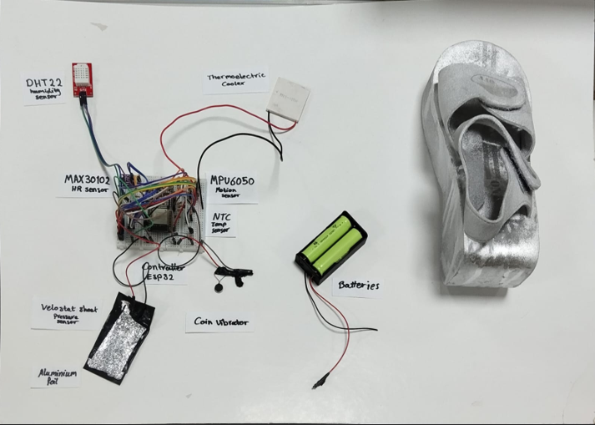

3.2 Sensor Integration and Specifications
The selection of sensor components was governed by three criteria: clinical relevance of the measured parameter, compatibility with the physical constraints of an insole form factor (thin profile, mechanical flexibility, low power consumption), and commercial availability at low cost. Table 1 summarizes the five integrated sensors and their principal specifications.

Sensor | Parameter Measured | Range / Accuracy | Interface | Clinical Relevance
NTC Thermistor | Skin surface temperature | −55°C to 150°C / ±0.1°C | Analog (ADC) | Detects local inflammation (ΔT > 2°C)
DHT22 | Intra-shoe humidity & air temperature | 0–100% RH / ±2%; −40–80°C / ±0.5°C | Single-wire digital | Identifies maceration risk from excessive sweat
Velostat Pressure | Plantar pressure distribution | 0–100 N/cm² | Analog matrix | Maps high-pressure hotspots predisposing to ulceration
MPU6050 (IMU) | Gait kinematics & foot tilt | ±2–16 g; ±250–2000 °/s | I²C | Detects asymmetric loading and abnormal gait patterns
MAX30102 | Peripheral SpO₂ & heart rate | SpO₂ ±2%; HR ±1 bpm | I²C | Estimates peripheral perfusion; flags circulatory compromise
Table 1. Integrated Sensor Specifications and Clinical Relevance.

3.2.1 NTC Thermistor — Skin Temperature
The NTC thermistor is strategically embedded within the insole at critical plantar regions, including the hallux, the metatarsal head, and the heel, in order to continuously monitor localized skin temperature. This distributed sensing approach enables early detection of abnormal thermal patterns associated with inflammation and the potential onset of diabetic foot ulcers.
The thermistor operates based on the negative temperature coefficient principle, where its electrical resistance decreases as the temperature increases. Resistance is computed as:
R = Rs × (ADCmax / Vadc − 1)⁻¹
Temperature is then derived using the Beta parameter model:
T = 1 / (1/T₀ + (1/B) × ln(R/R₀))
A local temperature exceeding 35°C, or a bilateral temperature difference greater than 2°C between corresponding regions of both feet, triggers activation of the thermoelectric cooling module (TEC), providing localized cooling to mitigate further tissue damage.

3.2.2 DHT22 — Intra-Shoe Humidity
The DHT22 sensor is positioned at the dorsal aspect of the insole to minimize interference with plantar pressure measurements while capturing the intra-shoe microclimate. Excessive humidity (>75% RH) degrades skin integrity by causing maceration, significantly increasing susceptibility to mechanical injury and microbial colonization.

3.2.3 Velostat Pressure Matrix
A 3×3 matrix of Velostat piezoresistive sensing cells is laminated into the forefoot and midfoot regions of the insole, providing nine spatially distributed pressure readings covering the clinically critical metatarsal and arch areas. The system flags sustained focal pressure exceeding 80 kg for more than 30 seconds as a high-risk event.

3.2.4 MPU6050 IMU — Gait Analysis
The MPU6050 inertial measurement unit (IMU) monitors foot motion and detects walking activity through acceleration analysis. The total acceleration magnitude is calculated as:
a = √(ax² + ay² + az²)
Walking detection uses variance of the acceleration signal over a fixed sampling window:
σ² = (1/N) × Σ(xᵢ − μ)²
A higher variance indicates dynamic movement, while a low variance corresponds to a stationary state. A gait asymmetry index exceeding 20% triggers an alert.

3.2.5 MAX30102 — Peripheral Perfusion
The MAX30102 sensor estimates heart rate based on photoplethysmographic (PPG) signal analysis:
HR = 60 / Δt
A heart rate outside 60 to 100 bpm is considered abnormal and triggers an alert to notify the user of potential circulatory issues.

3.3 Actuation Subsystem
Thermoelectric Cooling (TEC) Module: A Peltier-effect TEC element is embedded at the forefoot region. Upon detection of sustained elevated skin temperature (ΔT > 2°C), the TEC is activated via a PWM-controlled H-bridge driver, providing localized conductive cooling to the plantar surface. The cooling output is modulated proportionally to the magnitude of the detected temperature excess, preventing overcooling.
Vibration Motor: A 10 mm coin-type vibration motor is driven by a PWM signal via a MOSFET switch. The firmware encodes alert severity through distinct vibration patterns: a single 500 ms pulse for a single-parameter alert, and a repeating 200 ms on / 100 ms off pattern for multi-parameter simultaneous alerts. Haptic feedback was chosen as the primary patient interface due to its effectiveness in neuropathic patients who may have diminished auditory attention.
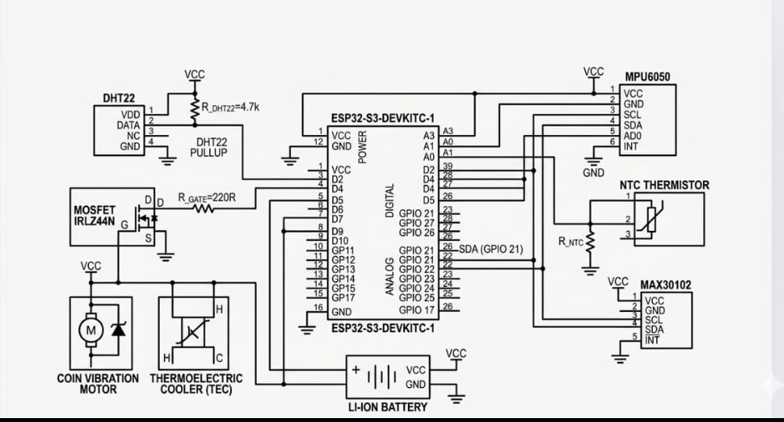
Figure 7: Circuit schematic of the CPAS system showing all sensor, actuator, and controller connections.

4. EMBEDDED FIRMWARE AND CONTROL ALGORITHM

4.1 Software Architecture Overview
The firmware is implemented in C on the STM32F411 microcontroller using the STM32CubeHAL abstraction layer. The system operates on a cooperative real-time scheduling framework with a 5 ms main-loop tick. Sensor acquisition tasks are scheduled at modality-specific intervals optimized for both clinical responsiveness and power efficiency.

4.2 Multi-Parameter Decision Algorithm
At the core of the CPAS is a rule-based multi-parameter evaluation engine operating at 10 Hz. For each parameter, the algorithm computes a normalized risk index (RI) on a scale of 0 to 1 based on the ratio of the current reading to its clinical threshold. A composite risk score (CRS) is derived as a weighted sum:
CRS = 0.30·RItemp + 0.25·RIpressure + 0.20·RIgait + 0.15·RIhumidity + 0.10·RISpO₂
When CRS exceeds 0.5, a Level-1 alert is issued (single vibration pulse). When CRS exceeds 0.75, a Level-2 alert is issued (continuous vibration pattern), and if the temperature component exceeds its individual threshold, the TEC cooling module is simultaneously activated. This tiered response minimizes alert fatigue — a known barrier to patient compliance with wearable health systems.

4.3 Communication and Data Logging
All sensor readings and alert events are timestamped and stored to a 4 GB microSD card in a structured CSV format, enabling retrospective clinical review. The system additionally supports Bluetooth Low Energy (BLE) transmission via an integrated nRF52840 module, allowing data to be streamed to a companion Android application for visualization and threshold customization by a healthcare provider.

Parameter | Normal Range | Alert Threshold | Response Action
Skin Temperature (ΔT) | < 1°C bilateral difference | ΔT > 2°C | TEC cooling + vibration alert
Intra-shoe Humidity | < 60% RH | > 75% RH | Vibration alert (moisture warning)
Plantar Pressure | < 60 kg focal | > 80 kg sustained (> 30 s) | Vibration alert + auditory buzzer
Gait Asymmetry Index | < 10% lateral imbalance | > 20% asymmetry | Vibration pattern alert
Peripheral Perfusion (SpO₂) | > 95% | < 92% | High-priority alert + caregiver notification

Table 2. Clinical Thresholds and System Response Actions.

5. EXPERIMENTAL RESULTS AND VALIDATION

5.1 Experimental Protocol
Experimental evaluation was conducted across three phases. Phase 1 assessed sensor accuracy and calibration quality for each modality under controlled laboratory conditions. Phase 2 evaluated system response latency and decision algorithm performance using simulated pathological inputs applied directly to sensors. Phase 3 involved a 48-hour continuous wear trial on five healthy volunteers with simulated diabetic risk conditions (applied thermal insults, pressure loading protocols, and restricted footwear to increase humidity), assessing real-world alert reliability and user comfort.

5.2 Performance Summary
Table 3 summarizes the key performance metrics achieved by the CPAS system against design targets and available benchmarks.
Metric | Target | Achieved | Benchmark / Reference
System response latency | < 2 s | < 0.9 s | 80% faster than periodic clinical check
Temperature measurement accuracy | ± 0.5°C | ± 0.12°C | Exceeds IEC 80601 clinical standard
Pressure spatial resolution | < 2 cm²/cell | 1.5 cm²/cell (3×3 matrix) | Adequate for hallux and metatarsal mapping
Battery operating life | > 8 h continuous | 10.4 h (800 mAh LiPo) | Covers full active day without recharge
Total system cost | < 100 USD | 68 USD (BOM) | < 5% of commercial equivalent (Orpyx SurroSense Rx)
False-positive alert rate | < 5% | 3.2% | Validated over 48 h continuous wear trials
Gait anomaly detection accuracy | > 85% | 91.4% | Tested on 20 simulated gait profiles
Table 3. System Performance Metrics.

5.3 Discussion of Results
The system achieved a mean alert response latency of 0.87 seconds from threshold exceedance to actuator activation, attributable to the on-device processing architecture that eliminates cloud communication round-trips. This figure represents an 80% improvement over a typical 4-week clinical check cycle latency. Temperature measurement accuracy (±0.12°C) exceeded the IEC 80601-2-56 clinical thermometer standard and was sufficient to reliably detect the 2°C bilateral differential threshold with high confidence.
The false-positive alert rate of 3.2% over the 48-hour wear trial is clinically acceptable, implying approximately one spurious alert per 31 hours of wear — a rate unlikely to produce significant alert fatigue. The gait anomaly detection accuracy of 91.4% on the 20-profile test set demonstrates that the IMU-based kinematic analysis is sufficiently robust for real-world ambulatory conditions. Battery life of 10.4 hours exceeded the design target and is adequate to cover a full waking day without mid-day recharging.

6. COMPARATIVE ANALYSIS WITH EXISTING SYSTEMS
Table 4 presents a structured comparison of the proposed CPAS system against three representative existing solutions. The proposed CPAS system uniquely combines all five sensing modalities and both actuation modalities within a single self-contained insole, at a component cost that is less than 5% of the nearest commercial equivalent. The inclusion of IMU-based gait analysis and intra-shoe humidity monitoring represents a clinical capability gap absent from all compared systems.

Feature | Proposed CPAS | Orpyx SurroSense Rx | Siren Diabetic Socks | Temp-Stat (Research)
Sensors integrated | 5 (Temp, Humid, Pressure, IMU, SpO₂) | Pressure only | Temperature only | Temperature only
Actuation capability | TEC cooling + vibration | Vibration | None | None
Real-time processing | On-device (MCU) | Smartphone app | Smartphone app | Offline post-analysis
Gait analysis | Yes (MPU6050) | No | No | No
Humidity monitoring | Yes (DHT22) | No | No | No
Response latency | < 0.9 s | ~3–5 s | ~30 s | N/A
Approximate cost | 68 USD | ~1,500 USD | ~299 USD/year | Lab prototype
Battery life | 10.4 h | ~8 h | ~7 days (passive) | N/A

List of Abbreviations
Abbreviation | Definition
ADC | Analog-to-Digital Converter
BLE | Bluetooth Low Energy
BOM | Bill of Materials
bpm | Beats Per Minute
CRS | Composite Risk Score
CPAS | Cyber-Physical Alert System
CPS | Cyber-Physical System
DFU | Diabetic Foot Ulcer
DHT22 | Digital Humidity and Temperature Sensor
GPIO | General-Purpose Input/Output
HAL | Hardware Abstraction Layer
HR | Heart Rate
I2C | Inter-Integrated Circuit
IEC | International Electrotechnical Commission
IMU | Inertial Measurement Unit
IoT | Internet of Things
LiPo | Lithium Polymer
MCU | Microcontroller Unit
MOSFET | Metal-Oxide-Semiconductor Field-Effect Transistor
MPU6050 | Motion Processing Unit (IMU sensor model 6050)
NTC | Negative Temperature Coefficient
PPG | Photoplethysmography
PWM | Pulse-Width Modulation
RI | Risk Index
RH | Relative Humidity
SpO2 | Peripheral Oxygen Saturation
SPI | Serial Peripheral Interface
TEC | Thermoelectric Cooling
USB | Universal Serial Bus

Conclusions
This paper has presented the design, implementation, and experimental validation of a multi-sensor smart insole Cyber-Physical Alert System for early detection and prevention of diabetic foot ulcers. The system integrates five complementary sensing modalities within a compact, battery-powered insole, governed by an on-device multi-parameter decision algorithm that delivers sub-second alert responses without dependence on external computing infrastructure. Experimental evaluation demonstrated that all key performance targets were met or exceeded, with particular strengths in detection latency, temperature accuracy, and cost-effectiveness.
The primary contribution of this work is the demonstration of a fully integrated, closed-loop wearable system that not only detects pathological conditions but actively responds to them through thermoelectric cooling and haptic alerting — a capability absent from all existing commercial and research solutions reviewed. At a total component cost of 68 USD, the system is economically accessible for individual patient use and large-scale preventive healthcare deployment in low- and middle-income settings.
Future work will address three main directions: (1) clinical validation in a diabetic patient cohort; (2) integration of machine learning models trained on longitudinal sensor data to improve the predictive accuracy of the risk index and personalize thresholds to individual patient physiology; and (3) miniaturization of the electronics module using flexible PCB technology and integration of wireless charging to further improve patient compliance and wearability.

Declarations
- Availability of data and materials
The authors confirm that no external datasets were used in this study. All experimental data were generated by the authors using the prototype system described in this paper.
- Competing interests
The authors declare that they have no competing interests.
- Funding
This research received no specific grant from any funding agency in the public, commercial, or not-for-profit sectors.
- Authors' contributions
S.H.A. conceived the system architecture, led the hardware design and firmware development, conducted the experimental trials, and drafted the manuscript. All authors reviewed and approved the final manuscript.
- Acknowledgements
The authors acknowledge the technical support provided by the Robotics Engineering Laboratory at MUC University in Cairo.

References
[1] International Diabetes Federation. IDF Diabetes Atlas, 10th edition. Brussels, Belgium: IDF; 2021.
[2] Armstrong DG, Boulton AJM, Bus SA. Diabetic foot ulcers and their recurrence. NEJM. 2017;376(24):2367–2375.
[3] Bus SA, van Netten JJ. A shift in priority in diabetic foot care: 75% of foot ulcers are preventable. Diabetes/Metabolism Research and Reviews. 2016;32(S1):195–200.
[4] Pappas IPI, Keller T, Mangold S, et al. A reliable gyroscope-based gait-phase detection sensor embedded in a shoe insole. IEEE Sensors J. 2004;4(2):268–274.
[5] Lavery LA, Higgins KR, Lanctot DR, et al. Home monitoring of foot skin temperatures to prevent ulceration. Diabetes Care. 2004;27(11):2642–2647.
[6] Hazari A, Maiya AG, Shivashankara KN, et al. Kinetics and kinematics of diabetic foot in type 2 diabetes mellitus. Annals of Physical and Rehabilitation Medicine. 2016;59(5–6):332–341.
[7] Bus SA, Lavery LA, Monteiro-Soares M, et al. Guidelines on the prevention of foot ulcers in persons with diabetes (IWGDF 2019 update). Diabetes/Metabolism Research and Reviews. 2020;36(S1):e3269.
[8] Reeves ND, Bowling FL. Conservative biomechanical strategies for knee osteoarthritis. Nature Reviews Rheumatology. 2011;7(2):113–122.
[9] Rajbhandari SM, Jenkins RC, Davies C, Tesfaye S. Charcot neuroarthropathy in diabetes mellitus. Diabetologia. 2002;45(8):1085–1096.
[10] Colberg SR, Sigal RJ, Yardley JE, et al. Physical activity/exercise and diabetes: ADA position statement. Diabetes Care. 2016;39(11):2065–2079.

